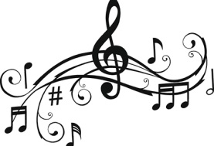**Music**

I do like a good sing song and over the years I have had the joy of listening to many different forms of music. Even in the early Christian church music was very important and has remained a part of Christian worship ever since, more or less. The Puritans were not so keen on music or Christmas but more on them later in the year.

In my early years and for quite some time I would have been listening to Gregorian chant which is a form of plainsong.

So what really is plainsong and why do we always think of Gregorian chant?

Plainsong is the unaccompanied church music where the words are the most important part of the music. There is no harmony in plainsong just melody.

You know the saying “singing from the same hymn sheet” well this could have been applied to Gregorian chant. Gregorian chant looked at the Mass and split it in to two parts the Mass Ordinary and the Mass Proper. The Mass Ordinary was the parts of the Mass repeated every time regardless of the time of year. The Mass Proper was the parts that changed on different Sundays or feast days throughout the year. People were standardising these and promoting this standardised version across Western Europe. The name Gregorian chant is associated with Pope Gregory 1st also known as Pope Gregory the Great. It is very unlikely he ever wrote any of the music himself, but as he was Pope at the time it is his name that we associate with this new standardised form of plainsong.

One great thing about the music I hear in church today is it is in English and Latin has taken a back seat. Don’t get me wrong I quite like Latin but it is not the easiest of languages to learn. Also a lot of the music we hear today is relatively new. Well it’s new to my old stones. Take Pachelbel’s Canon for example that was not written until about 1694. A firm wedding favourite today, there is a theory that it may have been written for a wedding. It is a bit convoluted so bear with me but the theory goes like this:-

Johann Pachelbel was the teacher of Johann Christoph Bach, big brother to Johann Sebastian Bach. When his pupil got married family and friends produced music for the ceremony and the Canon could have been one of these pieces.

All of this has been pieced together by the German musicologist and Bach scholar Hans-Joachim Schulze.

Pachelbel was an organist as well as a composer; this should come as no real surprise as just about all the composers from this Baroque period were both organists and composers. You have the large family of Bach, Handel and Domenico Scarlatti. As there has to be an exception to every rule you then have Vivaldi the virtuoso violinist, teacher and priest.

As for Widor’s Toccata that was not written until 1879 so in my life time that is like last month!

Churches and organs go together like hands in gloves. My own organ was installed in 1895 and sits in the St Catherine’s Chapel. Here is a picture of it.

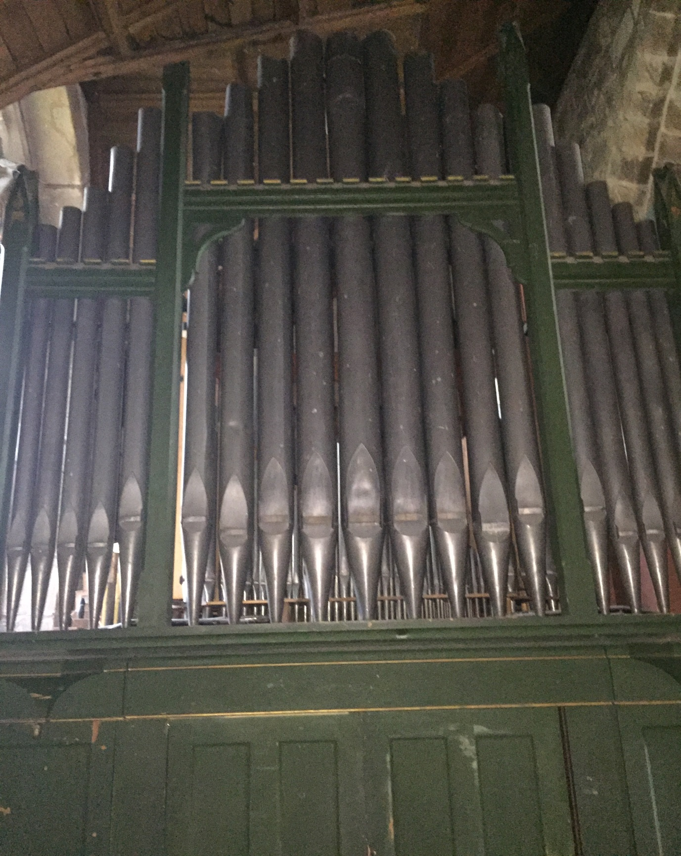

At the moment we are in the process of researching the organ so hopefully I can talk more about this at a later date.

**Trivia Alert**

Did you know that the keyboards on an organ are called Manuals?

It comes from the Latin word manus meaning hand.

How could I talk about music and not mention my bells. There are 8 of them in total and luckily they have not been affected by all the work that I need to have done. In June 2018 there was an open day to inviting people to have a go at bell ringing. Now with the help of some friends from St John’s in Bromsgrove I once again have my own bell ringers who meet every Monday evening. This coming Easter is special for them as they will be able to ring the bells without any further supervision. I am very proud to say my bells were also rung in November 2018 as part of the nationwide commemoration of the 1400 bell ringers who lost their lives in World War I.

Music has also been a great way for my friends to raise some money to help me. In February a musical afternoon was held in the church and after the singing there was an afternoon tea to refresh all the voices.

On Saturday 11th May this year the Alcester Male Voice Choir are holding their annual concert in Worcester Cathedral and they have very kindly allowed a retiring collection in support of the Stoke Prior Tower Fund i.e. me.

Tickets for the event are available from the AMVC Box Office on 07752 563 068 or 07886 139 781

On Saturday 18th May at 7.30pm the choir Taran Tara will be performing at St Mary de Wych in Wychbold and as this is my sister church the proceeds of the performance will go to the Stoke Prior Tower fund. Tickets are £10 and this will include after concert glass of prosecco and nibbles. Tickets can be obtained by calling 01527 861 247